**Research Report on the Pre-Planning on the usage of UAVs in civilian evacuation situations**

By: Jayanth Pandit and Yousuf Khalid

**Concept**

Our concept for a drone-based pre-planning system involves multiple systems that will be required to work together in order to properly plan pre-plan an escape route in case of a natural disaster. There are some obvious conditions and assumptions set for this. These assumptions are as follows:

1. The drone is assumed to be at the location that a group of evacuees are
2. The location of the evacuees is assumed to be somewhere that would appear to be inescapable
   1. This is based on the likely assumption that the evacuees are in a state of panic and shock, therefore preventing logical reasoning and investigation
   2. This is also based on the assumption that there is no person experienced in either escaping a natural disaster or one who is trained as a disaster-responder
3. The drone is capable of computationally calculating a path of escape that the evacuees can follow

The purpose of this report is to explain a concept for the third assumption and how that can be met through the usage of pre-disaster mapping, algorithm simulation testing, and point-to-point direct communications through disturbance-filled atmospheres.

Our concept for a pre-planning escape route-mapping system involves the following components:

1. System of UAVs (Unmanned Aerial Vehicles) capable of reaching positions at altitudes and locations that humans could possibly get trapped in
2. Direct communication network between UAVs as a system of routers in a disaster-like environment with an atmosphere full of disturbance is unlikely to be reliable. A direct communication network is also possible unreliable but there is a greater chance of it succeeding
3. Simulation system that allows drones to be placed into different situations where it is required to utilize a searching algorithm to compute the shortest and safest path of escape
   1. This assumes that the drone has already reached the position from which it will begin computing

These are the components of our concept for a pre-planning system of multiple drones in which each drone will need to be utilized individually, and in groups, depending on the severity of the situation, to algorithmically compute a path of escape for a group of human evacuees. We will now discuss the prior research we conducted on this topic.

**Literature Review**

In consideration of our proposed solution to the pre-disaster section of the usage of drones in civilian evacuation, we researched important relating topics like path planning and obstacle detection with cameras, algorithmic pathfinding, and LiDAR sensor usage. We looked at several papers relating to these topics.

Before discussing literature, a background of the usage of these drones is necessary. We plan to use these drones in the role of aiding first responders during a civilian evacuation. Evacuations are always chaotic and difficult to control, and any help offered to first responders and organizers will be crucial to evacuating and saving lives. First responder organizations like the police departments, fire battalions, paramedics, and dedicated evacuation response staff often have resources stretched thin and are inadequate when dealing with the sheer scale and unpredictability of disasters. Drones could serve in a variety of capacities to aid these first responders and our research intends to formulate new applications of drones in the field of evacuation response. One application that drones could serve in areas is communication drones or signal drones where they relay signals from organizers to evacuees in ways that normal signals cannot reach. The main application will be as pathfinders for evacuees and organizers. Drones can be used to search for safe evacuation paths before and during a disaster as UAVs, unmanned aerial vehicles, can get to and image places that humans cannot access.

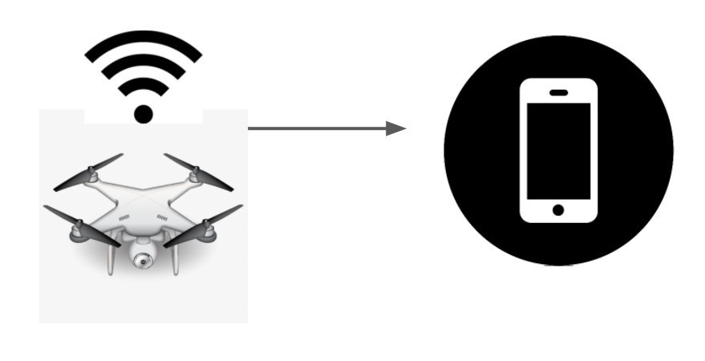

Some of the papers that we reviewed were concerned with the algorithm that the drones would deploy to do exactly that, search through an area for the best escape route. Obstacles can be pre-programmed or simulated for the drones and the drone must then identify a path considering all the simulated debris. This path can then be marked for later use if an actual disaster were to happen. During a disaster, drones can serve the same purpose. They can search through actual debris fields and disaster ruins and search for safe and easy paths that evacuees could use to escape an area and get to safety. Several algorithms were mentioned in these papers, including PSO (Particle Swarm Operation), WOA (Whale Optimization Algorithm). One paper was specifically about the testing of different algorithms and their computing cost and quality in deciding a safe path through a field of obstacles. This experiment tests these searching algorithms, with different path-finding scenarios. Some include a few large obstacles while others include several smaller obstacles. It also runs scenarios where the path is clearly defined to a human but not as well defined to a machine. Each algorithm is used to find multiple paths and decide which path is the best based upon its travel cost and obstacle value. The algorithms are graded upon how good of a path it finds and how much computing power it needs to find that path. Through several such tests on all the algorithms across multiple different scenarios, the DGBCO (Dynamic Group Based Cooperative Optimization) algorithm proved to be the best searching algorithm because of its unique dynamic grouping capabilities.

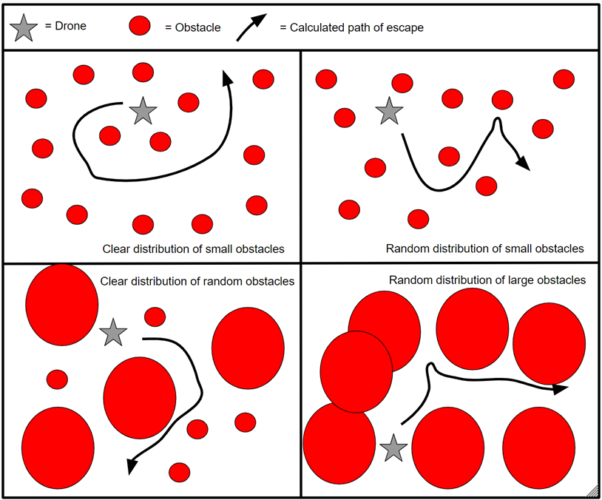

Drone’s path finding experimentation with varied obstacle distributions

Another paper discusses the usage of big data resources to plan and analyze vehicle routes during an evacuation scenario. This paper's focus is wildfires, but the concepts can be transferable to other disasters as well. It writes that there are two primary streams of traffic when a disaster occurs. One stream involves the evacuees, and the other stream involves the first responders. This is a common occurrence in all sorts of evacuations, from buildings on fire to entire city-wide evacuations. The paper also writes that this application was tested in a wildfire in British Columbia.

One paper dealt with a specific testing scenario as well as different applications for the usage of drones. This paper discusses the pre-disaster 3-D mapping of cities, specifically over the city of Victoria, British Columbia. This was the first mapping mission over an urban area approved by the Canadian aviation authority. The images were captured through sense Fly eBee Plus fixed-wing drone with real-time kinematic/post-processed functionality, with the goal being to assess the quality of pre-disaster data about geospatial accuracy of buildings and landmarks.

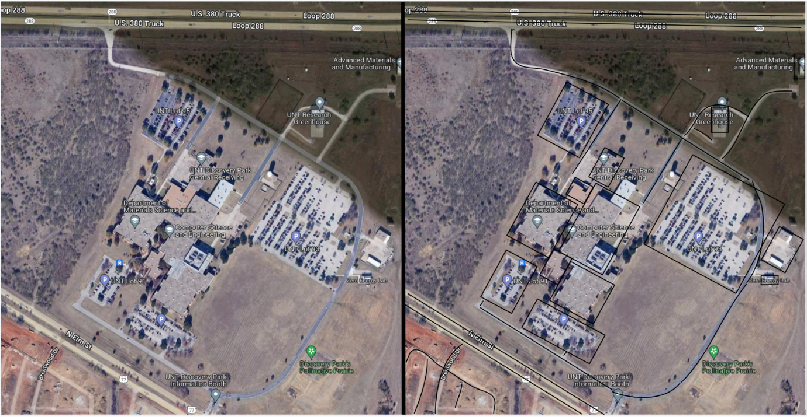

Landscape (left) is scanned by a drone, creating an outline of objects (right)

These papers are all useful in deciding how a pre-disaster planning and path-finding system would work. Through our literature review, we have found that a combination of the DGBCO algorithm and a network of connected drones will be effective in tracking the movements of a group of evacuees, deciding what paths they can take to escape the situation, and how best to distribute the resources that first responders and evacuation staff have available.

When planning for disasters, redirecting citizens to safer areas away from natural disasters is essential in mitigating potential loss of life. Our first article discusses the need for drones and UAV integration to maximize the effectiveness of evacuations among all disasters. The paper points out the importance of using drones and UAV systems together to achieve improved reconnaissance in evacuation scenarios, allowing for improved tracking of people from the disaster. The data collected from tracking the movement of people can help drones direct citizens towards more practical evacuation routes while helping national guards in planning and allocating resources, among many other uses. The second article highlights the need for specialized networks for drones to deal with many different problems, ones which can be used for predicting the disaster by structural and environmental monitoring, information analysis for forecasting, and early warning systems. When citizens do not have enough time to evacuate from a city, they need to be directed towards safer areas in a city. The previously mentioned “specialized networks” solve this problem, allowing drones to receive signals from their central controller with ease, therefore making them relays between the emergency services and evacuation organizers and the evacuees and first responders.

We also investigated literature that is specifically related to specialized topics like LiDAR, path planning, and infrared camera use on drones. The first paper that we found related to how autonomous drones would conduct path planning operations in a safe manner. The paper’s researchers focused on several possible situations where the drone was to calculate the reaction to the situation before the situation began. They stated that their experimental data proved that their system of autonomous drones could appropriately react to situations where an escape path needed to be calculated and executed.

Another article specified the wide range of lidar sensors that could potentially be used for both civilian and military applications. Regarding its civilian uses, lidar is particularly useful in capturing high-resolution 3-D data from reasonable distances. The paper focused on the practical uses of lidar in capturing information in bleaker weather, such as natural disasters, as a way of collecting data on the direction, power, and potential duration of the natural disaster. It also discussed new developments in radar that could enable cameras to identify singular people moving on the ground, opening potential uses of lidar beyond capturing 3-D data of large objects. This is relevant to our research as it enables further accuracy in both our plans to track the movements of people pre-disaster and to analyze the storms, hurricanes, and tornadoes using our high resolution, 3-D lidar scanning system.

**Strategy**

We spent some time studying the fundamentals of the A* searching algorithm and we saw why it is a good tool to utilize in this project. We understand that it is simply a version of the Dijkstra searching algorithm that uniformly searches all possible paths of interest. Dijkstra is useful when multiple paths need to be considered before the most optimal path is determined. However, as this is fairly time consuming, approximately O(nlog(n)). This could be detrimental when seconds matter during an evacuation. A* is slightly better as it includes a heuristic system that calculates the distance between the start and whatever the end node may be using comparative lengths analysis and removes the paths that are too long for it to compute. Assume there are multiple paths that a drone must survey during a disaster. Of the 6 paths that could be used, say that 2 are determined to take longer to compute and traverse than the others. The drone’s recursive algorithm would then drop those 2 paths and their accompanying base nodes and continue recursively searching the remaining 4 paths. This way, time is not wasted computing paths that will not provide any useful output while allowing the drone to follow the most efficient path. When looking at which paths, it takes in two primary factors (it also takes in other factors in the case of a new obstacle), weight and distance. Weight and distance are added together to get the total amount of effort needed to get a drones from point a to b, with the routes taking too much effort being put last in priority.

**Next Steps**

When looking at future steps to be taken in a pre-disaster situation, we must focus on using drones as a means of delivering much-needed medical and food supplies before a natural disaster hits. The importance of delivering such supplies cannot be understated, as keeping potential survivors properly maintained, such as in a flood scenario where survivors cannot be quickly rescued, requires them to, in the meantime, live off any rations they may have on them. It is therefore vital for us to plan and deliver any needed essential supplies that people may need in these scenarios. Drones can be used to quickly transport said supplies quickly and efficiently, especially using the different path finding and neural network systems mentioned above in our study.

We can also investigate more assessment software, where drones will look at the conditions leading up to the natural disaster, such as humidity, overall building strength, and possible evacuations routes to assess the overall danger of the situation, along with different possible precautions that can be taken to limit the danger to both citizens escaping the disaster and those who are stuck in the disaster. Running these simulations of disasters based on predictions of disaster magnitude can help city planners dedicate resources toward fixing potential problems that may come about before a disaster is even happening or to see potential fatality surges in a currently active natural disaster, dealing with these larger vulnerabilities.

**References**

1. Z. Qadir, M. H. Zafar, S. K. R. Moosavi, K. Le and M. A. P. Mahmud, "Autonomous UAV path planning optimization using Metaheuristic approach for pre-disaster assessment," in IEEE Internet of Things Journal, doi: 10.1109/JIOT.2021.3137331.
2. S. Keivanpour, "Internet of things in Optimizing Emergency logistics of Wildfire: A Review and Application Perspective in Canada," 2021 International Conference on Electrical, Computer and Energy Technologies (ICECET), 2021, pp. 1-6, doi: 10.1109/ICECET52533.2021.9698250.
3. S. A. Shah, D. Z. Seker, S. Hameed and D. Draheim, "The Rising Role of Big Data Analytics and IoT in Disaster Management: Recent Advances, Taxonomy and Prospects," in IEEE Access, vol. 7, pp. 54595-54614, 2019, doi: 10.1109/ACCESS.2019.2913340.
4. Á. Restás and Z. Dudás, "Some aspect of human features of the use of Unmanned Aerial Systems in a disaster-specific division," 2013 International Conference on Unmanned Aircraft Systems (ICUAS), 2013, pp. 1030-1036, doi: 10.1109/ICUAS.2013.6564791.
5. S. Ahmed, M. Rashid, F. Alam and B. Fakhruddin, "A Disaster Response Framework Based on IoT and D2D Communication under 5G Network Technology," 2019 29th International Telecommunication Networks and Applications Conference (ITNAC), 2019, pp. 1-6, doi: 10.1109/ITNAC46935.2019.9077975.
6. M. Erdelj, E. Natalizio, K. R. Chowdhury and I. F. Akyildiz, "Help from the Sky: Leveraging UAVs for Disaster Management," in IEEE Pervasive Computing, vol. 16, no. 1, pp. 24-32, Jan.-Mar. 2017, doi: 10.1109/MPRV.2017.11.
7. A. Boukerche and R. W. L. Coutinho, "Smart Disaster Detection and Response System for Smart Cities," 2018 IEEE Symposium on Computers and Communications (ISCC), 2018, pp. 01102-01107, doi: 10.1109/ISCC.2018.8538356.
8. A. French, M. Mozaffari, A. Eldosouky and W. Saad, "Environment-Aware Deployment of Wireless Drones Base Stations with Google Earth Simulator," 2019 IEEE International Conference on Pervasive Computing and Communications Workshops (PerCom Workshops), 2019, pp. 868-873, doi: 10.1109/PERCOMW.2019.8730845.
9. Z. Yang et al., "Evaluation of Smart Response Systems for City Emergencies and Novel UV-Oriented Solution for Integration, Resilience, Inclusiveness and Sustainability," 2020 5th International Conference on Universal Village (UV), 2020, pp. 1-51, doi: 10.1109/UV50937.2020.9426215.
10. Restas, A. (2015) Drone Applications for Supporting Disaster Management. World Journal of Engineering and Technology, 3, 316-321. doi: 10.4236/wjet.2015.33C047.
11. Kucharczyk, M. and Hugenholtz, C. H.: Pre-disaster mapping with drones: an urban case study in Victoria, British Columbia, Canada, Nat. Hazards Earth Syst. Sci., 19, 2039–2051, https://doi.org/10.5194/nhess-19-2039-2019, 2019.
12. C. Alex and A. Vijaychandra, "Autonomous cloud based drone system for disaster response and mitigation," 2016 International Conference on Robotics and Automation for Humanitarian Applications (RAHA), 2016, pp. 1-4, doi: 10.1109/RAHA.2016.7931889.